Autonomous Vehicle Parking Design Document

Terminology 3
Questions, Assumptions and Limitations 4
Questions: 4
Assumptions: 4
Limitations: 4
Task Statement 5
Inputs to the Algorithm 6
Time: 6
Average speed: 6
Starting position: 6
Ending position: 6
Width of Parking Space: 6
Dimensions of the Vehicle: 6
Parking Methods: 6
*Parking Topologies*: 7
Algorithm 10
Inputs 10
ALGO_PART_1: Moving the vehicle from starting point to entry point of parking lane: 10
ALGO_PART_2: Moving the vehicle from entry point of parking lane to entry point of parking spot: 11
ALGO_PART_3: Parking at the parking spot: 11
Parallel Parking in a Parallel Parking Spot: 11
Forward Parking in a 2-Way Parking Spot: 12
Reverse Parking in a 2-Way Parking Spot: 12
Forward Parking in a 1-Way Parking Spot: 12
Flow chart for the Algorithm 14

Terminology

Parking Spot: Marked area in which the vehicle can be parked.
Parking Spot Boundaries: The two lines that enclose the parking spot area.
Parking Lane: The lane which leads to parking slots. There could be many parking lanes in a parking lot.
Parking Lot: The area in which the parking lanes are marked.

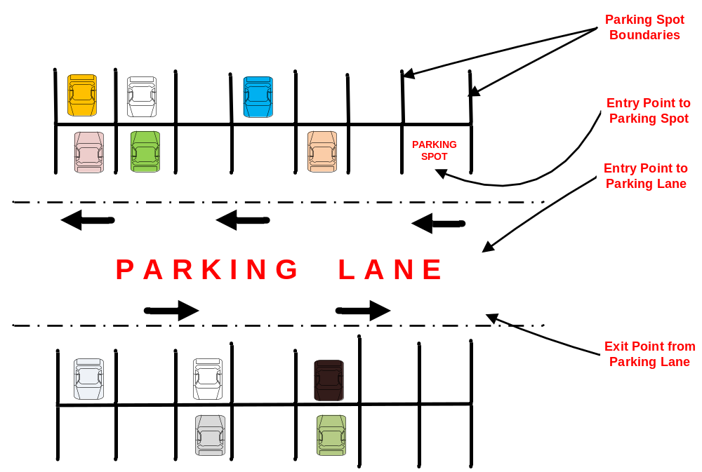

Questions, Assumptions and Limitations

Questions:

Assumptions:
- We will assume that the topology of the parking lots will be provided with parking lanes and parking spots marked with parking spot boundaries.
- We will assume that the entire parking lot can be plotted in a XY plane. Following plot shows 2 parking lanes and a parking spot in a parking lot.

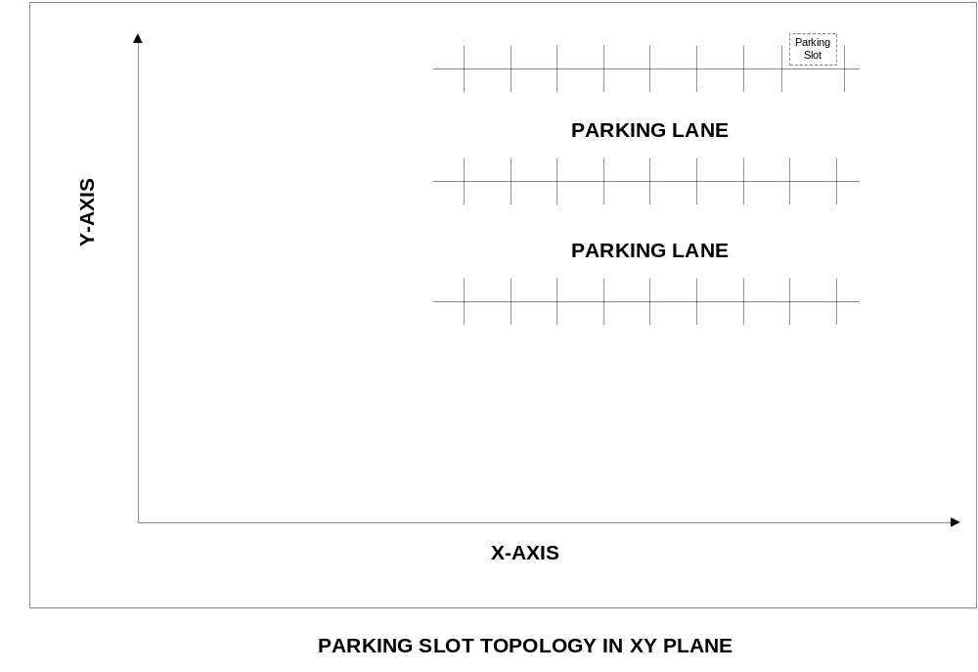

Limitations:
- First pass of the Algorithm will address starting position and ending position to be in XY plane only. No Z plane. E.g. If starting position is in first floor, ending position will also be in first floor.
- Parking lanes are open ended on both ends. There will not be any obstacles (Walls/Trees) blocking entry/exit into parking lanes from both ends of the parking lane.

Task Statement
The task is to develop an Algorithm for parking assistance in autonomous vehicles.
Assume that an autonomous vehicle needs to be parked in a parking lot. Let us assume that it knows its current position via GPS or other sensors. Let us assume that it is instructed to reach a parking lot whose position is also known and given to the machine. The task is to find an optimal trajectory from its current position to the parking lot position in two ways (a) forward parking, (b) reverse parking. Assume a certain width of a standard parking lot and the dimensions of a mid-sized vehicle which can be parked in the parking lot.
Develop an algorithm and implement it in Python and generate plots for the trajectories. The algorithm should take inputs like time for parking, average speed while carrying out this action etc.

Inputs to the Algorithm
Time:
This input parameter provides the time that the autonomous parking process should take. The parking process can be completed before the time limit expires, but it should not be completed past the allotted time, provided by the user.

Average speed:
Also, an input parameter, and is the speed at which the car should move, on average, for the entire trip. The car can have higher or lower instantaneous speeds, but the final average speed for the entire trip must be equal to the user input.

Starting position:
Input parameter which can be provided in an (x,y,z) coordinate system. The starting coordinate is used by the vehicle in order to begin its optimal trajectory within the given time and average speed constraints.

Ending position:
Input parameter which can also be provided in an (x,y,z) coordinate system. The ending coordinate can be used to calculate the optimal trajectory distance, by applying the distance formula using the starting and ending coordinates.

Width of Parking Space:
Provided by the user; we also know that the width of the parking space is sufficient enough for the autonomous vehicle to park without exceeding the maximum dimension.

Dimensions of the Vehicle:
Also provided by the user; it is known that the dimensions of the vehicle are large enough to fit in the appropriate parking space provided.

Parking Methods:
The parking methods have been provided by the user and are used depending on the parking topologies. The three main parking methods are:
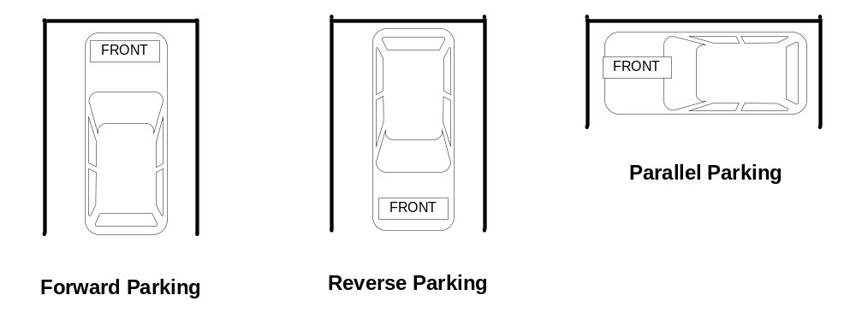

- Forward Parking: Most common parking method; front bumper of car faces inward and rear-end of the car faces outward.
- Reverse Parking: This parking method is the opposite of forward parking; the front bumper of the car faces outward, allowing the car to be removed easily.
- Parallel Parking: Occurs when the car is parked sideways, and generally requires more effort and time, as opposed to forward and reverse parking.

*Parking Topologies*:
The parking topology input is not provided by the user but is an essential input for the autonomous parking algorithm to work. The three possible topologies are:
Two Way Parking: This is a traditional parking layout, where the car has both an entry and exit option. Therefore, the car can either choose to be parked forwards or in reverse in the parking space.

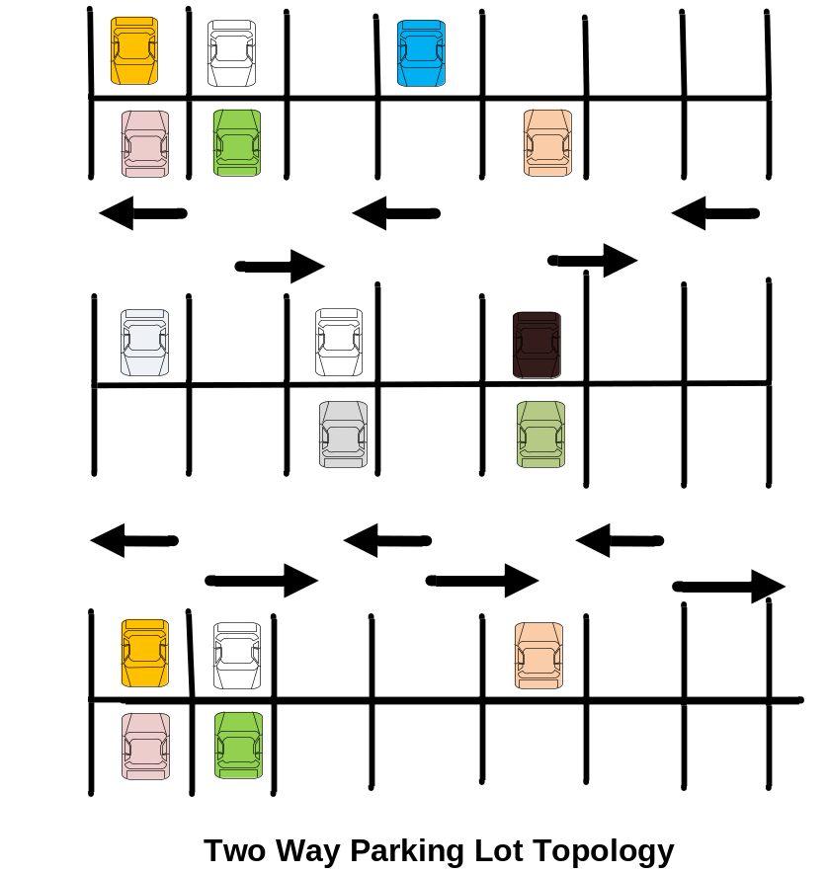

One Way Parking: This parking layout has only an entry option, and therefore the car must be only parked in the forwards method.

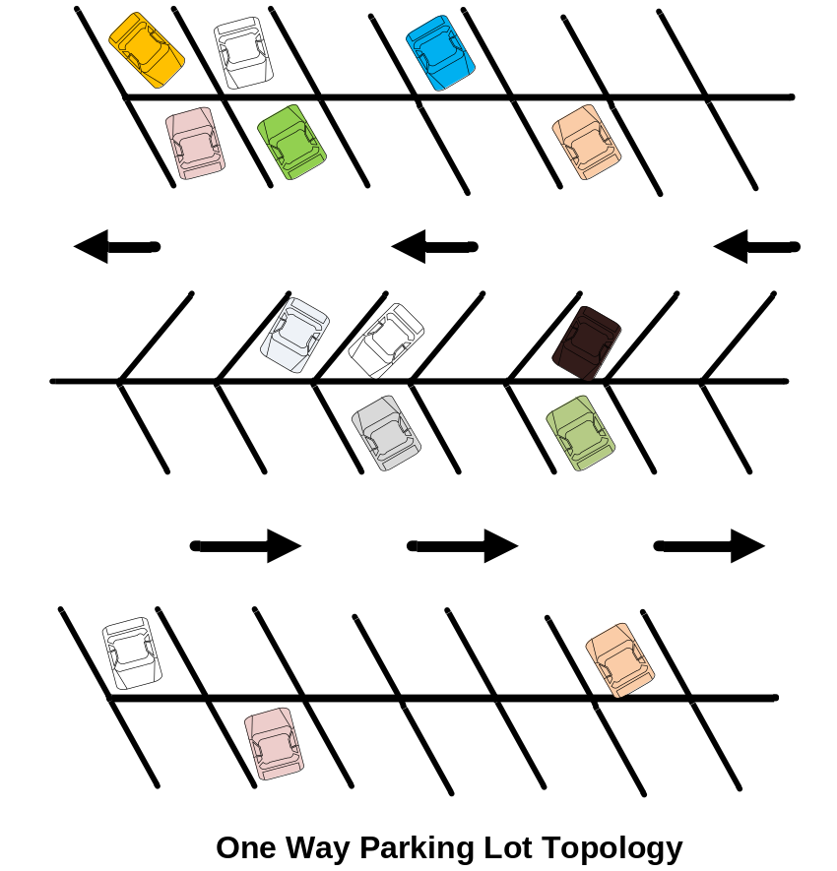

Parallel Parking: This parking layout allows the car to be parked sideways. It is not the most common parking topology but can be used to fit cars outside of a traditional parking lot.

Algorithm
This section describes the Algorithm to
Inputs:
- Time taken to complete the parking process
- Average speed of vehicle
- Starting position
- Parking lot topology (non-given user-input)
- Choice of parking method (forward/reverse/parallel parking)
- Ending position

With the user input we know the starting point in an (x,y) coordinate plane. Assume, for this simple parking lot, that the parking lot only deals with the x and y coordinates. The algorithm is broken up into 3 major components and is as follows:

ALGO_PART_1: Moving the vehicle from starting point to entry point of parking lane:
- Take the user input of the start position of the vehicle.
- With the start position coordinates, move the vehicle to the entry point of the parking lane.

ALGO_PART_2: Moving the vehicle from entry point of parking lane to entry point of parking spot:
- From the entry point of the parking lane, move the vehicle to the entry point of the parking spot.
- Once the vehicle has reached the entry point of the parking spot, based on the user's initial selection of a parking method, (forward/ reverse/parallel parking) start the parking process of the vehicle.
- We also know from the parking lot topology and the ending position coordinates, whether we should turn right or left from the entry point of the parking spot to reach the end point of the parking spot.

ALGO_PART_3: Parking at the parking spot:

After the car has reached the entry point of the parking spot, the following inputs can be utilized to determine if the possible parking method is a success or failure, given the parking lot topology.
Table for Possible Parking Successes or Failures

User Input Park Method: (Forward Park/Reverse Park/Parallel Park) | Parking Lot Topology:  (Parallel Lot, 2-Way Lot, 1-Way Lot) | Success or Failure to park
Forward Parking | Parallel Lot | Failure to Park
Reverse Parking | Parallel Lot | Failure to Park
Parallel Parking | Parallel Lot | Success to Park (Refer to Parallel Parking Section for Steps to Parallel Park)
Forward Parking | 2-Way Lot | Success to Park (Refer to Forward Parking Section for Steps to Forward Park- in a 2-Way Lot)
Reverse Parking | 2-Way Lot | Success to Park (Refer to Reverse Parking Section for Steps to Reverse Park
Parallel Parking | 2-Way Lot | Failure to Park
Forward Parking | 1-Way Lot | Success to Park (Refer to Forward Parking Section for Steps to Forward Park- in 1-Way Lot)
Reverse Parking | 1-Way Lot | Failure to Park
Parallel Parking | 1-Way Lot | Failure to Park

Parallel Parking in a Parallel Parking Spot:
- By now, we already know the final parking spot coordinates (provided by the user) and to turn either right or left of the entry point of the parking spot.
- If the final parking spot (destination point) is to the left of the entry point of the parking spot, do the following:
  - First move forward until half the vehicle crosses the boundary line.
  - Next, put the car gear in reverse before backing up into the parking spot.
  - Rotate the wheels 90 degrees clockwise, and slowly back up the car into the parking space.
- If the final parking spot is to the right of the entry point of the parking spot, do the following:
  - First move forward until half the vehicle crosses the boundary line.
  - Next, put the car gear in reverse before backing up into the parking spot.
  - Rotate the wheels 90 degrees counter-clockwise, and slowly back up the car into the parking space.

Forward Parking in a 2-Way Parking Spot:
- By now, we already know the final parking spot coordinates (provided by the user) and to turn either right or left of the entry point of the parking spot.
- If the final parking spot (destination point) is to the left of the entry point of the parking spot, turn left at an angle of 90 degrees and park in the parking space.
- If the final parking spot is to the right of the entry point of the parking spot, turn right at an angle of 90 degrees and park in the parking space.

Reverse Parking in a 2-Way Parking Spot:
- By now, we already know the final parking spot coordinates (provided by the user) and to turn either right or left of the entry point of the parking spot.
- If the final parking spot (destination point) is to the left of the entry point of the parking spot, do the following:
  - First, move forward and cross the boundary closer to the front end of the car, until the car's rear end aligns with the boundary line that was just crossed.
  - Now, put the car gear in reverse before backing up into the parking spot.
  - Rotate the wheels 90 degrees clockwise, and slowly back up the car into the parking spot.
- If the final parking spot is to the right of the entry point of the parking spot, do the following:
  - First, move forward and cross the boundary closer to the front end of the car, until the car's rear end aligns with the boundary line that was just crossed.
  - Now, put the car gear in reverse before backing up into the parking spot.
  - Rotate the wheels 90 degrees counter-clockwise, and slowly back up the car into the parking spot.

Forward Parking in a 1-Way Parking Spot:
- By now, we already know the final parking spot coordinates (provided by the user) and to turn either right or left of the entry point of the parking spot.
- If the final parking spot (destination point) is to the left of the entry point of the parking spot, turn left at an angle of 45 degrees and park in the parking space.
- If the final parking spot is to the right of the entry point of the parking spot, turn right at an angle of 45 degrees and park in the parking space.

Flow chart for the Algorithm
Add information here...

